**DAILY ONLINE ACTIVITIES SUMMARY**

|  |  |  |  |  |  |  |  |  |
| --- | --- | --- | --- | --- | --- | --- | --- | --- |
| **Date:** | **06-06-2020** | | | | | **Name:** | **Shiza Amreen.j** | |
| **Sem & Sec** | **4th sem B sec** | | | | | **USN:** | **4AL18CS078** | |
| **Online Test Summary** | | | | | | | | |
| **Subject** | | **Data Communication** | | | | | | |
| **Max. Marks** | | **30** | | **Score** | | | **26** | |
| **Certification Course Summary** | | | | | | | | |
| **Course** | **Introduction to Cyber Security** | | | | | | | |
| **Certificate Provider** | | | **GreatLarning** | | **Duration** | | | **5.5 hours** |
| **Coding Challenges** | | | | | | | | |
| **Problem Statement:**  **1.**[**Write a program in C to rotate an array by N positions.**](https://github.com/orgs/alvas-education-foundation/teams/2nd-year/discussions/103)  **2.Write a Java Program to find the second-highest number in an array.** | | | | | | | | |
| **Status: Completed** | | | | | | | | |
| **Uploaded the report in Github** | | | | | **yes** | | | |
| **If yes Repository name** | | | | | **Lockdwown_coading** | | | |
| **Uploaded the report in slack** | | | | | **yes** | | | |

Online Test Details:

Today we had Data Communication IA-3, I have attended the test and got 26 out of 30.

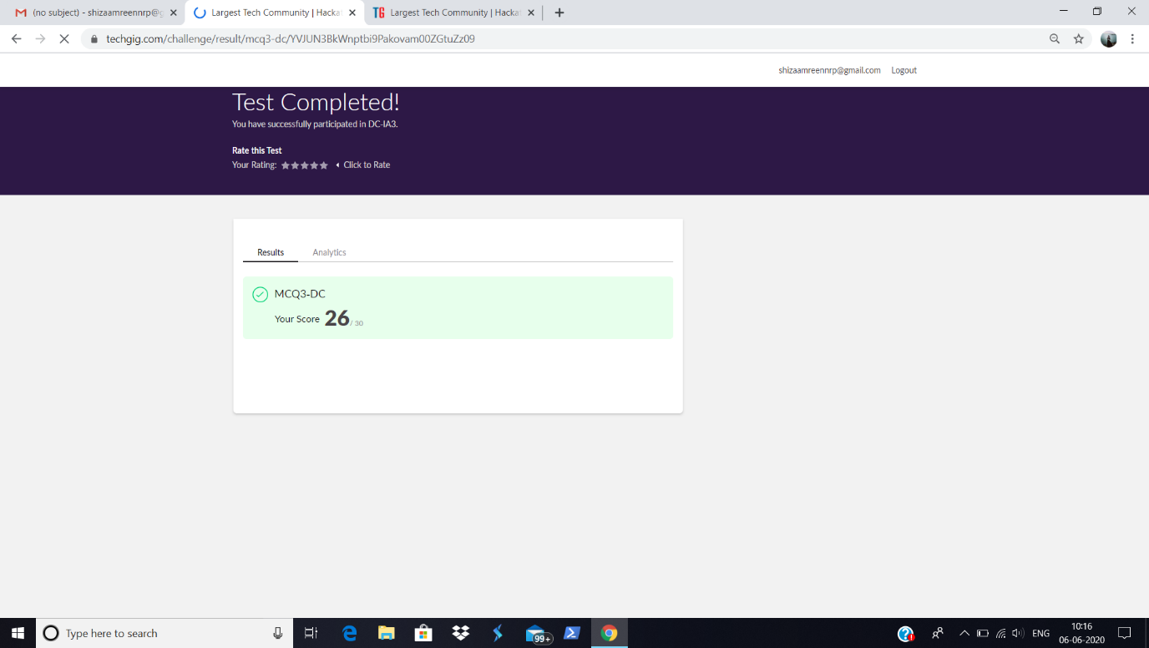

Certification Course Details:

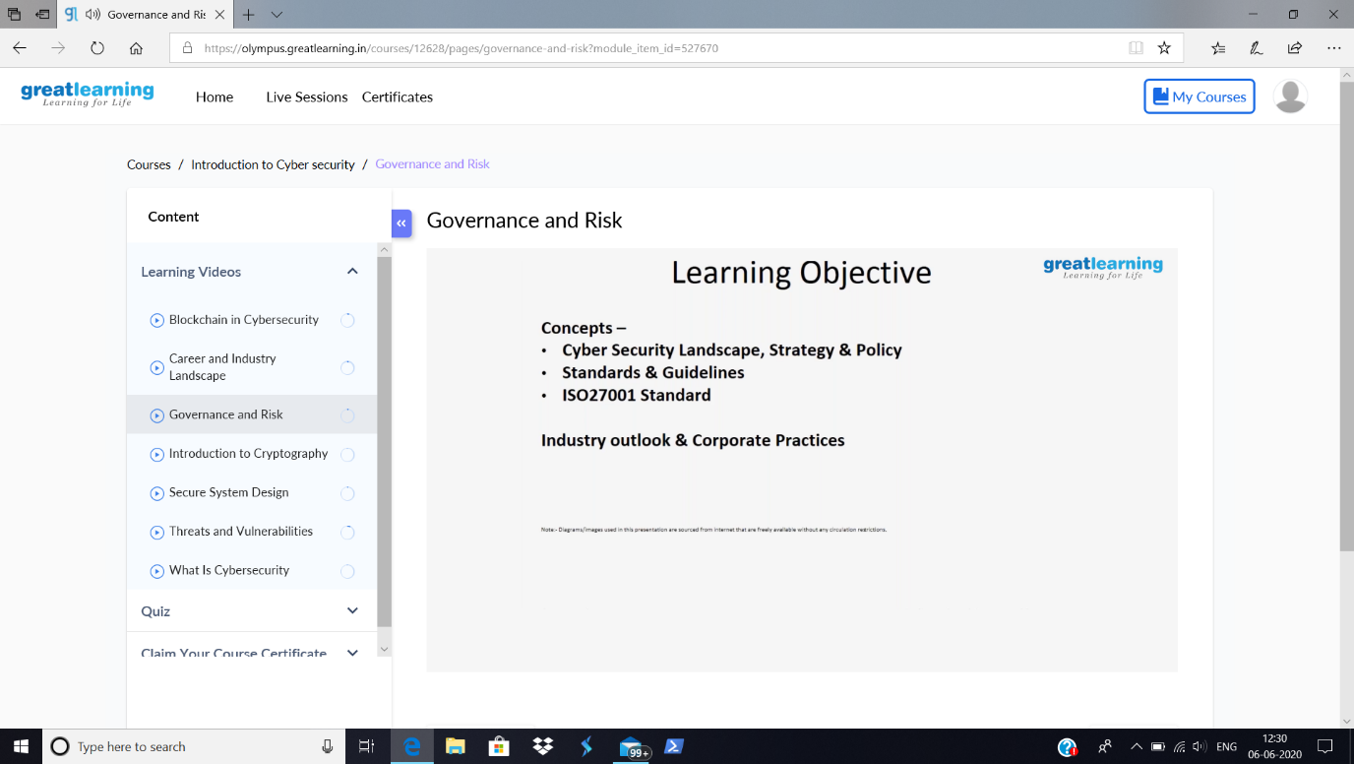

Today in the course, Introduction to Cyber Security, I have learnt about the Cyber Security and its Government policies.

Coding Challenges Details:

|  |
| --- |
| **Problem Statement:**  **1.**[**Write a program in C to rotate an array by N positions.**](https://github.com/orgs/alvas-education-foundation/teams/2nd-year/discussions/103)  **2.Write a Java Program to find the second-highest number in an array.** |

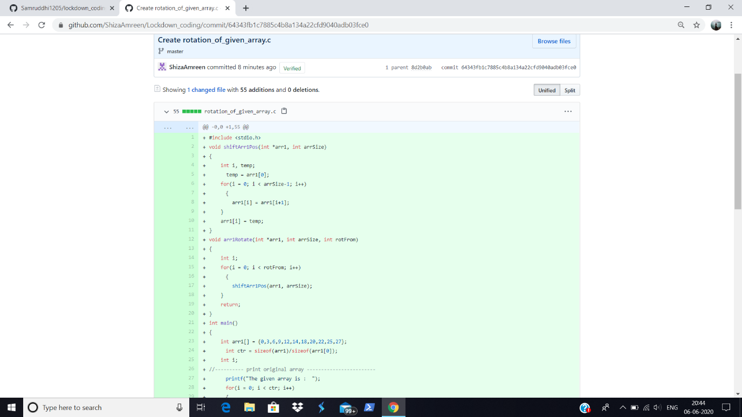

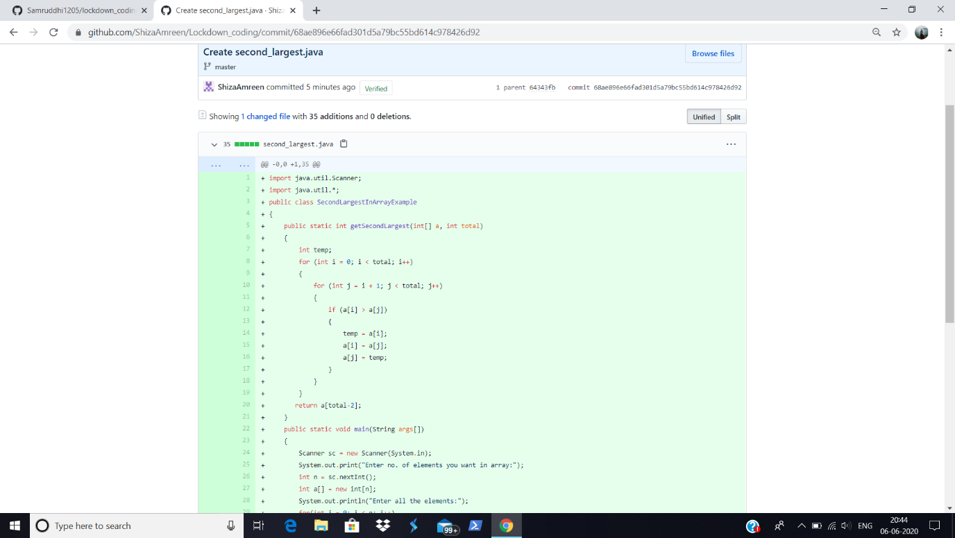

I have written the code for given problem statements and have submitted in my github repository, Lockdown_Coding.

<https://github.com/ShizaAmreen/Lockdown_coding/commit/64343fb1c7885c4b8a134a22cfd9040adb03fce0>

<https://github.com/ShizaAmreen/Lockdown_coding/commit/68ae896e66fad301d5a79bc55bd614c978426d92>